**HTML** 🡺 hypertext markup language

🡺 data presentation and UI designing (sign up, login, registration, search form…)

🡺We can design static web pages

**CSS** 🡺 Cascading Style Sheets

🡺 Used to change look & feel of webpage (html elements)

🡺It helps to present data more effectively, attractively & animations

**JavaScript 🡺**it provides logical support to html pages

🡺 its works like as back-end for html/css

🡺used to develop responsive web pages

Html, css & JavaScript are web technologies, these techs are used to develop **web applications**.

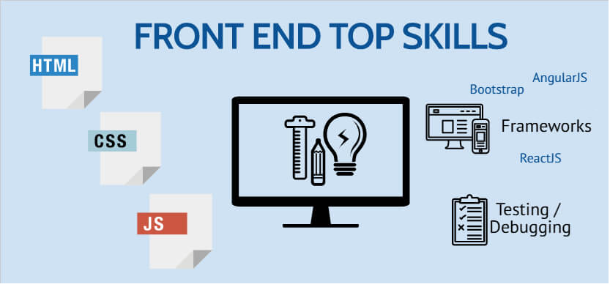

**WHAT IS APPLICATION OR SOFTWARE?**

Application is an Automation process of manual business operations (human being work) by using a programming language.

**TYPES OF APPLICATIONS OR SOFTWARES**

We can create an application or software in following flavors:

1. **Desktop:** The applications which are installable in local systems are called desktop applications.
2. **Mobile:** The applications which are installable in mobile phones or tablets downloaded from play store for android and apple store for ios.
3. **Web:** The applications which are deployable in any server and can be accessible from any location using a browser.

**WHAT IS WEB APPLICATION?**

Web applications are network enabled applications. We can deploy any web applications in servers and we can access them over the network using server ip address and application name.

In computing, a **web application** is a client–server software **application** which the client (or user interface) runs in a **web** **browser** and it contains web documents in the form electronic pages (web pages).

**A web application typically contains following three layers:**

**Presentation layer** is a user interface (views) which are accessible from any web browser.

**Business layer** is a server-side program which is nothing but automation of business rules. Client layer will interact with the business layer to persist data.

**Data layer** is database software where we can store client related data. Business layer will interact with the data layer.

**HOW MANY TYPES OF WEB APPLICATIONS WE HAVE?**

A webpage is an electronic page developed on HTML.

A web page is a group of elements.

Collection of WebPages or web documents is called web application (website).

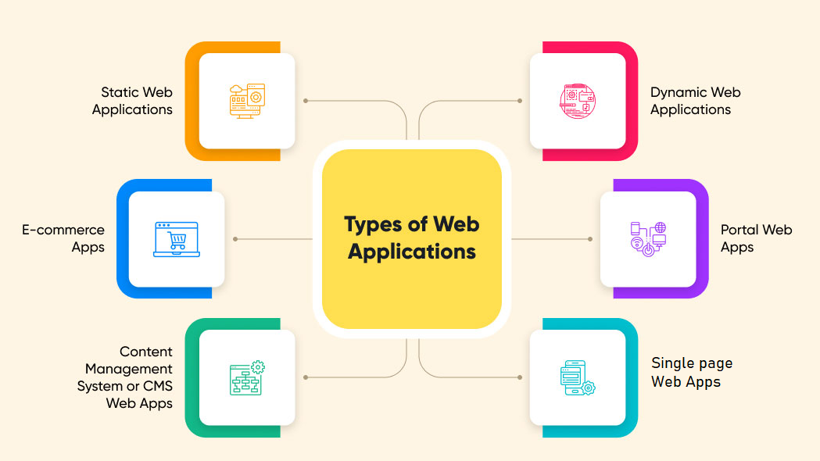

**STATIC WEB APPS:**

* The static web app directly delivers the content to the end user’s browser without fetching any data from the server. Most static web apps are known to be simple and effortless to develop across the web.
* HTML, CSS, and JavaScript are used to develop most static web applications.
* You can also add GIFs, animations, videos in static web apps.

**DYNAMIC WEB APPS:**

* A web application that generates the data in real-time based on the user’s request and server response, is known as a dynamic web application.

**Eg**: Facebook

**SINGLE PAGE APPS:**

* A single-page application runs entirely within a browser and doesn’t require page reloading.

**Eg**: Gmail

**E-COMMERCE APPS:**

* A web application that helps users electronically buy or sell goods over the internet is called an e-commerce web app.

**Eg:** Amazon

**CMS APPS**

A content management system (CMS) allows website owners to create, edit, and publish content, including images, text, and video, without involving a technical team. You can modify content through an admin panel without any knowledge of programming language.

Ex: Webflow, Wordpress

**PORTAL WEB APPS:**

* A portal web application is a website that provides access to many different pages and links.
* Portal web applications are often used for online shopping, news sites, blogs, and search engines.
* A portal web application's main idea is to browse through different content without leaving the site.
* **Eg:** telangana.gov.in

**Network**

Collection of computers interlinked together is called a network. First network name is **ARPANET** (Advanced Research Projects Agency Network). First protocol in the IT industry is FTP (File Transfer Protocol).

**Internet**

Internet stands for international networking.

The Internet is a network of connected computers. No company owns the Internet; it is a cooperative effort governed by a system of standards and rules. The purpose of connecting computers together, of course, is to share information.

**A Brief History of the Web**

The Web was born in a particle physics laboratory (CERN) in Geneva, Switzerland in 1989. There a computer specialist named “**Tim Berners-Lee”** first proposed a system of information management that used a “hypertext” process to link related documents over a network. He and his partner, **Robert Cailliau**, created a prototype and released it for review. For the first several years, web pages were text-only.

**Tim Berners-Lee** 🡺 WEB (1989-1990)

🡺 Html (HyperText Markup Lang)

🡺 WWW

🡺 W3C org

http

**The World Wide Web Consortium**

World Wide Web Consortium (called W3C) is the organization that oversees the development of web technologies. The group was founded in 1994 by Tim Berners-Lee, the inventor of the Web, at the Massachusetts Institute of Technology (MIT).

**Tim Berners-Lee (WWW/HTTP), Cerf & Kahn (TCP/IP), Baran, Davies, Klein rock & Roberts (packet networking), Bob Metcalfe (Ethernet).**

**Server**

A **server** is a computer or system that provides resources, data, services, or programs to other machines, known as clients, over a network/inet.

In theory, whenever computers share resources with client machines, they are considered **servers.**

a **server** stores all the data associated with the websites that are hosted by it and shares that info with all computers and mobile devices (like yours) that need to access them.

**Client**

A client is a device that connects to and uses the resources of a remote computer, or server.

Clients may use a desktop or a laptop or a tablet or a mobile phone or a TV or a car etc.

The device which is used by the user is called a “Client”.

**User**

The person who is working on/operating a client machine is known as User or end-user.

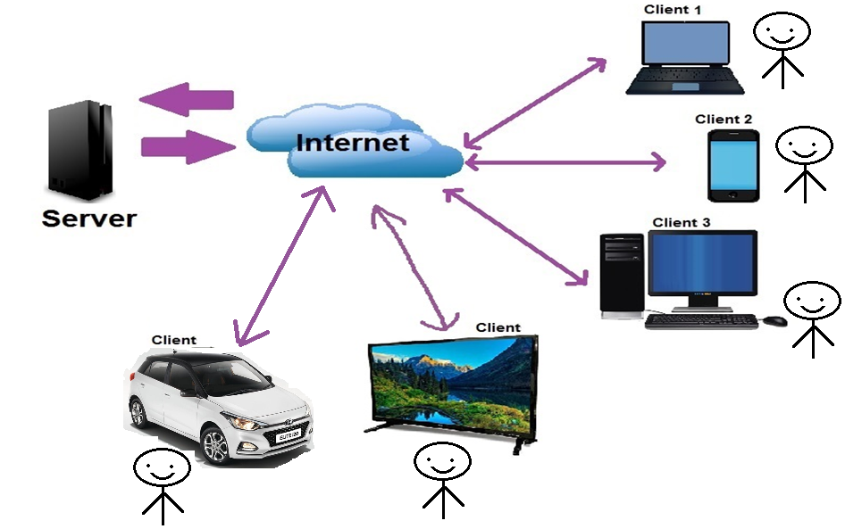

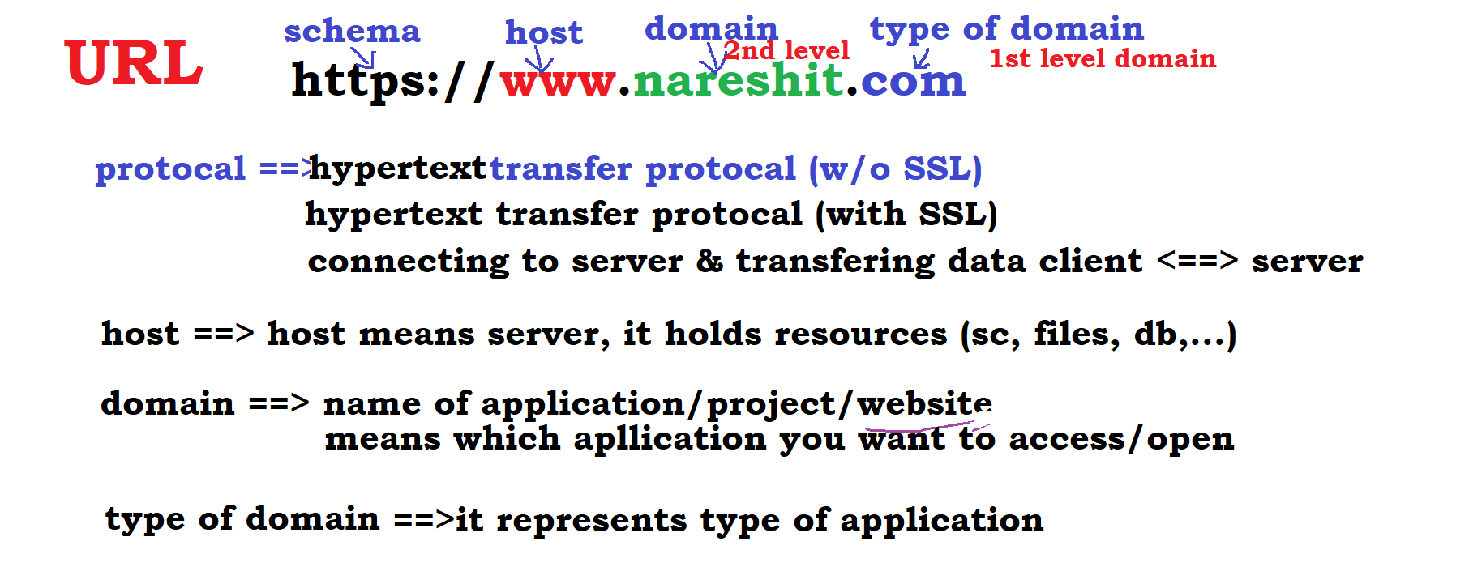

**What is web browser?**

It is client-side lightweight software installed in client machine. It sends http request from client to server; it takes http response from server.

Browser provides navigation among web pages, and browsers executes html, css, JavaScript files and displays output to user.

**List of Computer Browsers:**

Internet Explorer(1995), Opera(1995), Mozilla Firefox(1998), Safari(2005), Google Chrome(2008) etc…

**Email:** Electronic mail services. It is a free service to communicate with other internet users. Email is invented by Shabeer Bhatia. Sabeer Bhatia is an Indian entrepreneur who founded the webmail company Hotmail.com.

**SMTP:** Simple Mail Transfer Protocol. It takes care of delivering emails from one server to another.

**MIME:** Multipurpose Internet Mail Extensions. It exchanges different kinds of data.

**Blog:** It is daily updating website or webpage. Every post displayed in reverse chronological order.

**Forum:** It is an online discussion website to exchange resources each other.

**Http:** It is a transfer protocol to exchange hypertext documents in the world wide web.

**Http(s):** Secured transfer protocol to exchange hypertext documents with the help of SSL (cipher text).

**Cipher text** is encrypted text. Plaintext is what you have before encryption, and cipher text is the encrypted result. The term cipher is sometimes used as a synonym for cipher text, but it more properly means the method of encryption rather than the result.

**What is HTML?**

It is specially designed hypertext for web browsers, with meaningful tags or elements in simple English language.

**HTML Versions**

From W3C organization there are fallowing versions released.

**Version Specification Release Date**

**1.0 N/A (HTML 1.0) 1993-dec/1994**

**2.0 HTML 2.0 24-Nov-1995**

**3.2 W3C: HTML 3.2 14-Jan-1997**

**4.0 W3C: HTML 4.0 24-Apr-1998**

**4.1 W3C: HTML 4.1 24-Dec-1999**

**5.0 WHATWG 28-Oct-2014**

**(Adv Markup Language For Mobiles)**

**5.1 W3C: HTML 5.1 -Nov-2016**

**(Adv Markup Language For Small Electronic Devices)**

**5.2 W3C: HTML 5.2 14-Dec-2017**

**HTML introduction**

1. HTML was developed by **“Tim-Berners-Lee**”, released in 1993 and maintained by W3C Org.

~~GML 🡺 SGML~~ 🡺 HTML

~~DHTML~~, XML, XHTML (XML+HTML), ~~WML~~ , UML

Web introduce => 1989/90

Which version is bare bone? Html1

Html dev based on which structure?

Html is sub set of which lang? SGML

2. HTML stands for “Hypertext Markup Language”.

“**Hypertext**” means the text that can be transferred from internet server to internet client.

**"Markup**" means which syntax will be in the form of tags or you simply "markup" a text document with tags that tell a Web browser how to structure it to display.

**“Language”** is an interface between web developer and web browser

3. Technically, HTML is not a programming language, but rather a markup language.

4. HTML is used to design "static web pages", means HTML is used to create elements (such as headings, paragraphs, icons, menus, logos, images, textboxes, button etc) in the web pages.

static webpage means, that pages always showing same information.

5. HTML is very easy to understand (no pre-requisites).

6. HTML is “client side tech”. That means the html code executes on the client browser but not in server.

7. HTML is supported by all the browsers such as Google Chrome, Mozilla Firefox, Microsoft Internet Explorer, Safari, Opera and other browsers.

Cross platform comp

8. HTML is used in all real time web sites today; html is the only language available in world for designing Web pages.

9. The file extension either "filename.html" or "filename.htm"

10. For working html no need installs any software, and browser is responsible for executing & producing output of html programs.

Typing & saving 🡺 notepad

Execution & result 🡺 Browser

Notepad++, editplus

VS Code, Sublime, Ec, netbeans

11. Html is error free programming.

(Displaying images, playing audio & video)

12. HTML is not a case sensitive language that means you can write the html code in either upper case or lower case.

13. HTML is an interpreter-based language. Browser interprets HTML code.

C, cpp, java, .net … 🡺 compiler

Html, javascript, oracle … 🡺 interpreter

Vlsi, algol, matlabs 🡺 Assembler

**Translators**: converting high level code (human) into machine level code (MP/OS) is called as translation. Who performs this operation those called translators.

**Types**: compiler, interpreter, assembler

interpreter 🡺 it translates code line-by-line and executes line-by-line (interpretation)

interpreter

html code 🡸===============🡺 machine code

(English) (Binary code)

**Tag:**

* A tag is a keyword, enclosed within "<" and ">" in HTML language.
* It is special kind of text placed between left angular brace and right angular brace(<tag_name>).
* Tag is predefined program, program is instructions / command to browser.
* Tag is used to display some specific output in the web page.
* Browser was not identified the tag; it shows blank page or it prints as text.
* tags also represented as elements.

**types of tags**

in html we have **two** types tags, those are:

🡺 **paired tags**

* Contains open tag and closing tag.
* Opening tag specifies starting point of operation/output, closing tag specifies ending point of operation/output.

Syn: **<tagname>** text **</tagname>**

**ex:** <html> ... </html>

<head> ... </head>

<body> … </body>

<script> ... </script>

<style> ... </style>

<p> … </p>

**note: paired tags also called as body-full tags**

🡺 **unpaired tags**

* contains only open tag.

Syn: <tagname> or <tagname/>

**ex:** <br/> <img/> <input/> <hr> <link> <meta>

**VOID** tags => ITS not RETURNING ANY VALUE

**Unpaired tags also called as body-less tags**

**Structure of HTML**

as per **W3C** we have to follow the following structure to design web pages (but it’s not comp).

**<!DOCTYPE html>**

**<html lang=”en”> 🡸 web page/document designing starts here**

**<head>**

**🡺web page settings here (like title, favicon, link external files, JS, meta data)**

**🡺1st executed**

**Ex: <title>, <link>, <meta>, <style>, <script> & <base>**

**</head>**

**<body>**

**🡺web page design here**

**🡺2nd executed**

**Ex: <form>, <h1>, <p>, <div>, <a>, <input>, <img>, <table> …**

**</body>**

**</html> 🡸 web page/document designing ends here**

Generally, html program contains three parts, those are:

**> versioning section**

**> head section**

**> body section**

**versioning section**

This is providing information to the browser which version we are using in the web page/program. So, browser is interpreting code and producing output as per given specification.

Syn: **<!DOCTYPE html version-url>**

HTML4.0:

**<!DOCTYPE html public "-//W3C//DTD HTML 4.0//EN" "http://www.w3c.org/TR/html4/strict.dtd">**

**<!DOCTYPE html> 🡸 use current version of HTML**

**C prog 🡺 compile 🡺 execute 🡺 o/p**

**C#.net 🡺 compile 🡺 execute 🡺 o/p**

**Html 🡺execute 🡺 o/p (web page)**

**public "-//W3C//DTD HTML 3.0//EN" "http://www.w3c.org/TR/html3/strict.dtd**

**public "-//W3C//DTD HTML 2.0//EN" "http://www.w3c.org/TR/html2/strict.dtd**

**<!DOCTYPE html>**

HTML5:

**<!DOCTYPE html> it uses current version of html**

strcit.dtd file (document type definition) contains definitions of tags and specifications.

**html tag**

The <html> tag represents the starting and ending of an html program. html tag contains two child/sub tags those are head tag and body tag.

**head tag**

head tag represents a non-content section (means not output) of the web page.

This information doesn't appear on the web page/in the browser (it's called as non-content), but it's used internally by the browser.

This tag is used to set icons, title, to provide some meta data (info about web app), css settings, java scripting etc...

head tag contains some child/sub tags, those are

**<link>, <title>, <meta>, <style>, <script> and <base> tags**

**body tag**

body tag represents content information (means output) of the web page.

this information appears on the web page/in the browser (it’s called content).

This tag is used to design UI or to display output.

body tag contains so many child/sub tags.

some of tags: **p**, **img, h1, table, div, a, table, audio, video, input, button, form, ol, ul, li, hr tags …**

**html is a collection of tags(elements) and every tag has some attributes.**

**how design & execute html programs**

⇒ open any text editor (sw) and type program.

notepad, editplus, notepad++, textpad, sublime, vs code, atom, coffee, ...

⇒ save that program with any name (.html or .htm) and anywhere in the system.

⇒ execution:

**1st Approach:** goto file location, then double click on file

**2nd Approach:** goto file location, then right click on file and click on open then select browser

**3rd Approach:** open any browser, then goto address bar and type filename with address.

for ex: d:/siva/test.html e:/test.html

**comment lines**

⇒ Comment lines are to provide some description about our program.

⇒ Comments are not executed by browser.

**Syn:**

**<!-- comments -->**

**heading tags**

These tags are used to print data/text in heading format.

html provides 6 heading tags, those are h1, h2, h3, h4, h5, h6.

These 6 tags are used to display headings in different sizes.

six tags are paired tags and block level elements.

Syn:

<h1> text </h1>

<h2> text </h2>

<h3> text </h3>

…

**Note:** inside the body section we can repeat any tag and no.of times.

**p tag**

> p stands for paragraph.

> this tag is used to display/print more lines of text (paragraph)

> its paired tag and block level.

> browser display an empty line(gap) between paragraphs

Syn:

**<p> text or info </p>**

**Note:**

**>**browser/html doesn't accept more than one space (space bar & tab key), means while designing the program we are given more space but browser prints only one space.

**>**browser/html doesn't accept enter key (line breaking), means while designing a program we use enter key but browser prints data without breaking line.

**br tag**

Ø br stands for break line (enter key)

Ø it moves the cursor to the beginning of the next line.

Ø its un-paired

**Syn: <br>** or **<br/>**

**Html entities**

=> Entities nothing but Special characters or html operators

=> Special characters are used to perform some task or to print some Symbols.

=> Special characters is a English word

**Syn:** **&**word**;**

Html hexa-decimal operators, these operators are starts with #

Hexa-dec base 16 🡺 0,1,2,3,4,5,6,7,8,9,a,b,c,d,e,f

**Syn: &#**hex-code**; &#6digits; &#4digits;**

**b** tag or **strong**

> b stands for bold

> b & strong tags used to print text in bold format

> both are paired tags & inline tags

Syn:

<b> text </b>

<strong> text </strong>

**I** or **em** tag

>i stand for italic (inclined)

>i & em tags used to print text in italic format

>i is paired

Syn:

<i> text </i>

<em> text </em>

**u tag**

> u stands for underline

> u tag used to print text with underline (draws a line base of text)

> u is paired tag

Syn:

<u> text </u>

**strikeout tag**

> strikeout tag used to print text with line (draws a line middle of text)

>strikeout is paired tag

Syn:

<strike> text </strike>

**superscript tag**

>this tag used to display text top of upper line

> superscript is paired tag

Syn:

<sup> text </sup>

**subscript tag**

>this tag used to display text bottom of baseline

> subscript is paired tag

Syn:

<sub> text </sub>

All these tags are paired tags & inline tags

**Span tag**

>span tag used for small textual data, like as error message, mandatory specification.

> in continuity of text, if we want to highlight couple of word or **letters**,

we use span tag

>its paired tag, inline tag

Syn: **<span>** text **</span>**

**pre tag**

> pre stands for pre-formatting (alignment)

> pre tag is used to print data/text, how we typed in same format

> pre is paired tag, block level

Syn:

**<pre> text </pre>**

**Label tag**

> label tag used for displaying prompting text.

> its paired tag, inline tag

Syn: <label> text </label>

**HTML Attributes**

⇒ Attribute is a special feature/setting of a tag.

⇒ Every tag they have attributes 99%

⇒ An HTML attribute is a piece of markup language used to adjust the behavior or display of an HTML element. For example, attributes can be used to change the color, size, or functionality of HTML elements.

⇒ HTML Attribute is something that we use in the starting tag of HTML Elements or HTML Tags which provides extra information about those HTML Elements or HTML Tags.

Syn:

**<**tagname **attribute="value" attribute=’value’ ...>**

**Note:**

⇒ Parameters(values) should be enclosed within “ “ or ‘ ‘ or without quotes.

⇒ Every attribute must be separated by a space

**Types of attributes**

**⇒ general attributes**

These attributes are common for most tags (99% of tags). These attributes are used to adjust the behavior or display of an HTML element, to provide extra information about those HTML Elements to the browser.

**those attributes are:**

**class, id, name, style, align**, **action, method, href, src, target, width, height, alt, title, lang, min, max, step, maxlength, type, checked, selected, value, readonly, placeholder etc…**

**⇒ event attributes**

**An event is a notification that is triggered when something changes in the browser.**

**With event attributes these events are directed to JavaScript which then responds to the event**.

These attributes are used to perform some logical operations.

logical operations we can perform by using JavaScript, these also called **dynamic attributes.**

By using event attributes From Html page we can trigger JavaScript code or we can call JavaScript functions

**attributes are:**

**on**click, **on**dblclick, **on**focus, **on**blur, **on**keypress, **on**keyup, **on**keydown, **on**submit, **on**change, **on**input, **on**reset, **on**select, **on**mousemove, **on**mouseout, **on**mouseover, **on**wheel, **on**load, **on**submit, **on**change etc…

**optional attributes**

same as gen attribute

there attributes are not comp to use

**ex:** lang, method, type, …

**title tag**

this tag used to set the title for a webpage, means every webpage they have individual title.

Web site => 10 web pages => 10 titles (1page : 1title)

its paired tag.

<title> is the sub tag of <head> tag.

**Syn:**

**<title>** text **</title>**

**Link tag**

🡺 Link tag used to set the favicon/logo for a webpage.

🡺 Also used to link with external files (css files, bootstrap file)

🡺 Unpaired tag.

🡺 <link> is the sub tag of <head> tag.

**Syn: <link rel=”icon” href=”filename”/>**

**Relative =>** icon or stylesheet

**Hyper reference** => address of image

.jpg .bmp **.png .jfif** .gif .tif **.ico .webp .svg**

**images**

> "img" tag is used to display images on webpage.

> in one web pages we can display any no.of images and any type of images.

.jfif .svg .jpg .bmp .gif .tif .png .webp

> its un-paired tag, and its inline element

Syn:

**<img** attributes**/>**

**Note:**

It is strongly recommended to place all images in side root folder or create sub folder with name images in root folder

**attributes:**

**src** => to specify which img you want to display

**width** => width of image (pixel)

**height** => height of image (pixel)

**title** => it is used to specify tool tip. (whenever mouse pointer comes on top of image)

**alt** => alternative text, if image not loaded in webpage/not display, we want to display text message to user it called as alt

+

global attributes

opacity: 0.5;

filter: blur(5px);

brightness(125%)

contrast(135%)

grayscale(100%)

invert(100%)

hue-rotate(180deg)

saturate(8)

sepia(100%)

drop-shadow(8px 8px 10px green)

**hyperlinks**

> a tag stand for "anchor”

>"a" tag is used to create hyperlink, hyperlinks are used to move from one webpage to another webpage.

>whenever user clicks on the hyperlink, it moves to the specified page.

> Destination page sometime within same application or other application.

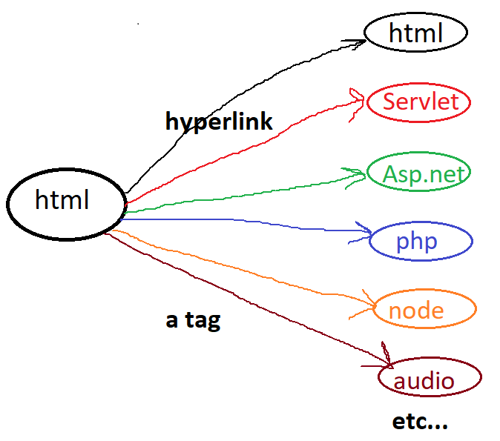



> by default, every browser provides built-in style for each hyperlink,

i.e blue color + hand symbol + under line.

we can customize these styles by using CSS.

> its paired tag, and inline element

**Syn:**

<a attributes>Display Text</a>

<a attributes> <img> </a>

**attributes:**

href : hyper reference, used to specify the address of webpage or web site, i.e whenever user clicks on this link, which page you want to open

url may be html page, server-side file, image, audio file, video, pdf file, documents etc...

href=”url”

“<https://www.abc.com/login.aspx>”

“” 🡺self-calling

“.” 🡺 home page of web site/home dir of web application

“#id” 🡺 it creates book marks (moving within same page)

target : where you want open destination page

_blank ==> opens the link in a window/tab

_self ==> opens the link in current working tab/window (its default)

_parent ==> opens the link in parent frame

_top ==> opens the link in full body of window

framename ==> opens the link in specified frame

**CSS**

* Cascading style sheets 3
* Released in 1996 & maintained by W3C org
* Used to change look/feel of html elements (makeover)

Like color, background, border, alignment, wallpaper, animations, size of element, padding, margin, opacity etc…

* Css provide only styles but not tags
* Style is group of properties

Where we can define styles?

We can define styles in 3 places, those are:

* Inline styles
* Internal styles
* External styles

Different ways to implement css:

**1stApproch (inline):**

Html tag and css properties are defined within the same line

Syn:- **<tag style=”property:value; property:value; … “**>

Unique styles or personal

**2ndApproch (internal):**

Html tags and css styles are designed in the same program, but not in same line.

Internal css should be implements in Style tag, style tag must be sub tag head tag.

Syn:-

**<style>**

tag { selector

property:value;  
 property:value;

…….

}

Tag {

property:value;  
 property:value;

…….

}

Etc…

**</style>**

**3rdApproch (external)**

Css styles are designed in separate file and should be save with “.css”, and html code designed in separate file saved with “.html”

Use link tag for mapping css file to html file

Syn: **<link rel=”stylesheet” href=”filename.css”/>**

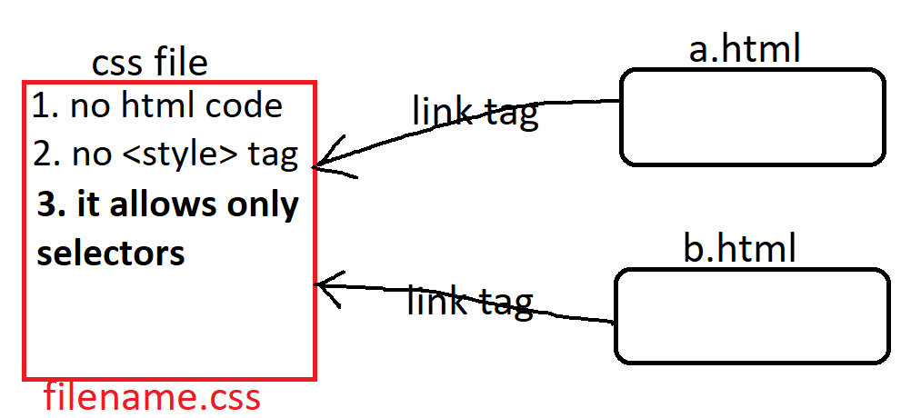

**note:**

* css attributes we can't use in place of html attributes.
* html attributes we can't in place of css attributes.

**html colors**

html supports 3types of patterns, those are

> named colors

> RGB colors

> Hexadecimal colors

**named colors:**

>it supports to write direct color name

>we have some limited colors

ex: white, black, red, green etc...

> Color names are not case-sen

**RGB colors:**

>RGB model specifies that the composition of 3 basic colors (Red, Green, Blue)

>RGB produces 16millions colors.

Syn: **rgb**(red,green,blue)

red => 0 - 255

green => 0 - 255

blue => 0 – 255

ex: **rgb**(10, 45, 201) 401%255 🡺146

**Hexadecimal number colors:**

>Hexadecimal model is the shortcut for rgb model

>Hexadecimal system ranges from 0 - 15

0,1,2,3,4,5,6,7,8,9,a,b,c,d,e,f

**Syn: #**RRGGBB 1,2 red 3,4 green 5,6 blue

ex: #1a4b68

**#RGB**

**e**x: #3d7

**Note:** in realtime "Hexadecimal model" is recommended.

these colors we can use for foreground color, background color, border color

etc..

for setting colors we have some attributes, those are

**color** 🡺 to set/to change foreground color (text color)

**background-color** 🡺 to set/to change background color

**border-color** 🡺 to set/to change border color (line color)

**box-shadow** 🡺 to set/to change shadow color

**text-shadow** 🡺 to set/to change text shadow color

**Note:** all these are CSS attributes. Support by Most of html tags

**Gradient colors**

background: #FC466B; /* fallback for old browsers */

background: -webkit-linear-gradient(to bottom, #3F5EFB, #FC466B); 🡸 Chrome 10-25, Safari 5.1-6

background: **linear-gradient**(to bottom, #3F5EFB, #FC466B); 🡸W3C, IE 10+/ Edge, Firefox 16+, Chrome 26+, Opera 12+, Safari 7+

**linear-gradient**(direction, color1,color2,…color-n)

dir: to left (r=>l)

to right (l=>r)

to top (b=>t)

to bottom (t=>b)

background: **linear-gradient**(to bottom, #3F5EFB 40%, #FC466B 60%);

-webkit-linear-gradient(to left, #3F5EFB, #FC466B);

linear-gradient(to left, #3F5EFB, #FC466B);

**background: radial-gradient(circle, rgba(2,0,36,1) 0%, rgba(38,38,162,1) 60%, rgba(0,212,255,1) 100%);**

**radial-gradient(shape, color1, color2, …color-n)**

radial-gradient(circle, rgb(131,58,180) 0%, rgb(29,166,65) 50%, rgb(252,176,69) 100%);

radial-gradient(circle, rgba(166,29,142,1) 57%, rgba(100,180,111,1) 78%, rgba(69,252,96,1) 100%);

**Note:** while applying gradient colors we have to use “**background**” property in place of “**background-color**”.

**working with list tags**

these tags are used to display data/info in points wise.

html supports three types of list, those are

Ordered list🡺 numbering

Unorderedlist 🡺 bulleting

**ol tag**

>ol stands for "Ordered List".

>it is used to display the text(names, colors, team names, course name...) with numbering.

>it supports 5types numbering, those are **1, A, a, i, I**. by default it displaying in number.

>by using "ol" tag we can create ordered list

>ol is paired tag & block level element

**li tag**

> li stands for "list item"

> li is sub tag of ol tag

> li tag is used to print text/data in points wise

> li is paired tag & block level element

Syn:

<ol attributes>

<li> text </li>

<li> text </li>

<li> text </li>

...

</ol>

**ol attributes:**

type : which type numbering to display (Default is 1)

start : from where u want to start numbering (default is 1)

reversed : to displaying numbers in desc order

**li attributes:**

value : used for restarting numbering with specified value

**ul tag**

>ul stands for "Un-Ordered List".

>it is used to display the list of items(names, colors, team names, course name...) with bulleting.

>it supports 3types bulleting, those are **dot, circle, square**. by default, is dot.

>by using "ul" tag we can create un-ordered list items

> ul is paired tag

>"li" tag used for creating list items

**Syn:**

<ul type="dot/circle/square">

<li> text </li>

<li> text </li>

<li> text </li>

...

</ul>

**dl tag**

>dl stands for Definition list (since html5 description list)

>dl tag used for to display definitions/full forms (collection of definitions)

>its paired tag

> "dt" and "dd" are sub tags of "dl" tag

> "dt" stands for definition title, "dd" stands for definition data.

> dt & dd are paired

Syn:

<dl>

<dt>title/word</dt>

<dd>information</dd>

<dt>title/word</dt>

<dd>information</dd>

<dt>title/word</dt>

<dd>information</dd>

...

</dl>

**fieldset tag**

> this tag used for drawing a common border around elements/tags.

> its paired tag and block level

> we can draw any no.of borders

**Syn:** <**fieldset** attributes>

<**legend**>text</**legend**>

Sub elements

</**fieldtset**>

**attributes:**

align : align of elements, it supports 3 alignments center, left, right

left is default align

border : style of line, thickness of line, color of line

width : width of box (size in % )

**legend tag**

>legend tag used for set title/heading for fieldset

>legend is sub tag of fieldset tag

>its paired tag

**Syn:**<legend attributes>Heading</legend>

**attributes:**

align :align of elements, it supports 3 alignments center, left, right

left is default align

color :

**div tag**

>div is a **container**, means its grouping elements/controls/components of html.

> inside div tag we can place any content like normal text or images.

>div tag is used to divide web page as no.of subpages/parts, each part is rep as div.

> for better maintained, effective design of web page and simplifying css code.

>its paired tag, and block level element

Syn: <div attributes>

contents

</div>

>one webpage may contains any no.of div tags.

display:flex; <== it displaying all elements side-by-side row wise or column wise

flex-wrap:wrap; <== it align element to next line

flex-direction <== it used to specifiy direction (order) of flex elements

flex-direction:row|row-reverse|column|cloumn-reverse;

flex-flow <== it combination of felx-wrap & flex-direction attributes.

flex-flow: direction wrap;

display:grid; <== it displaying all elements in rowsXcols

grid-template-columns <== no.of columns to display (width of columns)

grid-template-columns:col1 col2 col3....;

:autoautoautoauto; <== 4columns

:300px 400px 250px; <== 3columns

:30% 30%; <== 2columns

:30% auto 400px;

grid-column-gap: Npx; <== it provides a gap between column to column

grid-row-gap: Npx; <== it provides a gap between row to row

grid-gap:Xpx; <== it provides a gap between row-row & col-col with same size

Note: its applicable on nested tags, means outer tag only we can apply grid

**table tag**

>table tag is used to display the data in form rows & cols in the web page.

> a table is a collection of rows, each row is collection of cells/col/field.

> a table is represented as <table> tag, a row represented as <tr> tag, a colheading is represented as <th> tag, data rep as <td> tag.

> table heading is represented as <caption> tag.

><thead> tag is rep of table head part, <tbody> tag is rep of table body part and <tfoot> tag Is rep of table footer part.

**table**🡺 used to draw a table, means it grouping no.of rows

**caption**🡺 to set main heading of table

**tr**🡺 table row, used to draw a row, means it grouping no.of columns

**th**🡺 table heading, used to set column headings

**td**🡺 table data, used to print the data in columns

**+**

since html4:

**thead**🡺 table head section

**tbody**🡺 table body section

**tfoot**🡺 table footer section

> all these 8tags are paired tags

> table, tr, caption, thead, tbody & tfoot are block level tags

> th & td are inline tags

**Syn:**

<table>

<tr>

<th>heading</th> <th>heading</th>

</tr>

<tr>

<td>data</td> <td>data</td>

</tr>

...

</table>

**NOte:**

<th> and <td> are sub tags of <tr>

<tr> is sub tag of <table>

**table attributes:**

border : border of table (0 means no border, 1-n border req)

align : alignment of table

width : width of table (%)

...

**th& td attributes:**

colspan : specifies the no.of columns to merge/expend

rowspan : specifies the no.of rows to merge/expend

...